Write Assembly Language program in 8086 for demonstrating the addition and subtraction Instructions.

**Experiment 1**

**Date: 01/11/2018**

**Program**

|  |
| --- |
| **name "add_sub"** |
| **org 100h** |  |
| **mov al,09H** |  |
| **mov bl,05h** |  |
| **add bl,al** |  |
| **sub bl,01h** |  |
|  |  |
| **mov cx,08h** |  |
| **print: mov ah,02h** |  |
| **mov dl,'0'** |  |
| **test bl,10000000b** |  |
| **jz zero** |  |
| **mov dl,'1'** |  |
| **zero: int 21H** |  |
| **shl bl,01h** |  |
| **loop print** |  |
|  |  |
| **mov dl,'b'** |  |
| **int 21h** |  |
| **mov al,0** |  |
| **int 16h** |  |
| **Ret** |  |

**Output:**

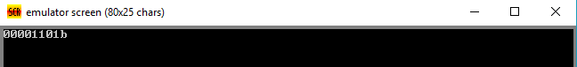

**Result:-**

The program was executed successfully.

Write Assembly Language program in 8086 to print “HELLO WORLD”.

**Experiment 2**

**Date: 01/11/2018**

**Program:**

|  |
| --- |
| **NAME "hello"** |
| **ORG 100h** |  |
| **JMP START** |  |
| **MSG: DB "HELLO WORLD",0DH,0AH,24H** |  |
| **START: MOV DX,MSG** |  |
| **MOV AH,09H** |  |
| **INT 21H** |  |
| **MOV AH,0** |  |
| **INT 16H** |  |
| **RET** |  |

**Output :**

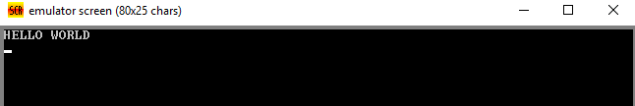

**Result:** - The program was executed successfully.

*Write Assembly Language program in 8086 for counting the number of characters in a given string of a zero terminated string.*

**Experiment 3**

**Date: 01/11/2018**

**Program: -**

|  |
| --- |
|  |
|  | **Name “counter”**  **org 100H** |
|  | **JMP start** |
|  | **str DB 'abcdefg hijklmnop qrstuvwxyz',0** |
|  | **start: LEA BX,str** |
|  | **mov AX,0** |
|  | **compare: cmp [BX],0** |
|  | **JE done** |
|  | **INC AX** |
|  | **INC BX** |
|  | **JMP compare** |
|  | **done: MOV BX,AX** |
|  |  |
|  |  |
|  | **MOV CX,08** |
|  | **print: MOV AH,2** |
|  | **MOV Dl,'0'** |
|  | **TEST BL,10000000B** |
|  | **JZ zero** |
|  | **MOV DL,'1'** |
|  | **zero: INT 21H** |
|  | **SHL BL,01H** |
|  | **LOOP print** |
|  | **MOV DL,'B'** |
|  | **INT 21H** |
|  | **MOV AL,0** |
|  | **INT 16H** |
|  | **RET** |

|  |
| --- |
| **Output:** - |
| **Result:-** The program is executed successfully. |  |

Write Assembly Language program in 8086 for finding the factorial of 5.

**Experiment 5**

**Date: 01/11/2018**

**Program:** -

**name "fact"**

**org 100h**

**jmp start**

**n db 5**

**start: mov al,01h**

**mov cl,00h**

**mov dl,n**

**next: cmp cl,dl**

**je done**

**inc cl**

**mul cl**

**jmp next**

**done: mov bl,al**

**mov cx,08h**

**print: mov ah,02h**

**mov dl,'0'**

**test bl,10000000b**

**jz zero**

**mov dl ,'1'**

**zero: int 21h**

**shl bl,01h**

**loop print**

**mov dl,'b'**

**int 21h**

**mov al,0**

**int 16h**

**ret**

**Output:** - 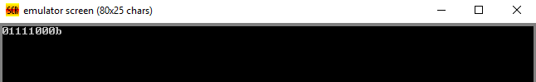

**Result:** - The program was executed successfully.

*Write Assembly Language program in 8086 for the conversion from centigrade (Celsius) to Fahrenheit calculation and vice-versa.*

**Experiment 6**

**Date:**

**Program: -**

|  |
| --- |
|  |
|  | **name"celsius"**  **org 100h** |
|  | **jmp start** |
|  | **tc db 10** |
|  | **tf db 100** |
|  | **result1 db "result in farenheit"** |
|  | **result2 db "result in celcius"** |
|  |  |
|  | **start: mov cl,tc** |
|  | **mov al,09h** |
|  | **imul cl** |
|  | **mov cl,05h** |
|  | **idiv cl** |
|  | **add al,20h** |
|  | **mov result1,al** |
|  | **mov bl,result1** |
|  | **call print** |
|  | **mov cl,tf** |
|  | **sub cl,20h** |
|  | **mov al,05h** |
|  | **imul cl** |
|  | **mov cl,09h** |
|  | **idiv cl** |
|  | **mov result2,al** |
|  | **mov bl,result2** |
|  | **call print** |
|  | **mov ah,0** |
|  | **int 16h** |
|  | **ret** |
|  |  |
|  |  |
|  | **print proc** |
|  | **pusha** |
|  | **mov cx,08h** |
|  | **p1: mov ah,02h** |
|  | **mov dl,'0'** |
|  | **test bl,10000000b** |
|  | **jz zero** |
|  | **mov dl,'1'** |
|  | **zero: int 21h** |
|  | **shl bl,1** |
|  | **loop p1** |
|  | **mov dl,'b'** |
|  | **int 21h** |
|  | **mov dl,0dh** |
|  | **int 21h** |
|  | **mov dl,0ah** |
|  | **int 21h** |
|  | **popa** |
|  | **ret** |

**Output: -**

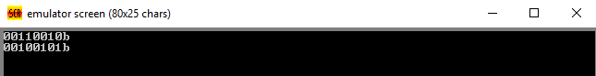

**Result: -** The program was executed successfully.

*Write Assembly Language program in 8086 for reversing a string.*

**Experiment 7**

**Date: 01/11/2018**

**Program:** -

|  |
| --- |
|  |
|  | **name"reverse"**  **org 100h** |
|  |  |
|  |  |
|  | **jmp start** |
|  | **string: db '!gnirts a si siht $'** |
|  | **start: lea bx,string** |
|  | **mov si,bx** |
|  | **next_byte:cmp [si],'$'** |
|  | **je end** |
|  | **inc si** |
|  | **jmp next_byte** |
|  | **end: dec si** |
|  | **do_reverse:cmp bx,si** |
|  | **jae done** |
|  | **mov al,[bx]** |
|  | **mov ah,[si]** |
|  | **mov [si],al** |
|  | **mov [bx],ah** |
|  | **inc bx** |
|  | **dec si** |
|  | **jmp do_reverse** |
|  | **done: lea dx,string** |
|  | **mov ah,09h** |
|  | **int 21h** |
|  | **mov ah,00h** |
|  | **int 16h** |
|  | **ret** |

**Output:** -

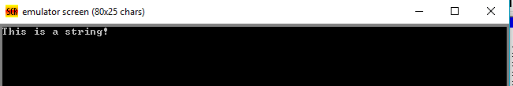

**Result:** - The program was executed successfully.

Write Assembly Language program in 8086 to make lowercase to uppercase string.

**Experiment 8**

**Date: 01/11/2018**

**Program:** -

|  |  |
| --- | --- |
|  | **name"lower_upper"**  **org 100h** |
|  | **jmp start** |
|  | **string db 20h,22h dup('?')** |
|  | **new_line db0dh,0ah,'$'** |
|  |  |
|  | **start: lea dx,string** |
|  | **mov ah,0ah** |
|  | **int 21h** |
|  |  |
|  | **mov bx,dx** |
|  | **mov ah,00h** |
|  | **mov al,ds:[bx+1]** |
|  | **add bx,ax** |
|  | **mov byte ptr[bx+2],'$'** |
|  |  |
|  | **lea dx,new_line** |
|  | **mov ah,09h** |
|  | **lea bx,string** |
|  | **mov ch,0h** |
|  | **mov cl,[bx+1]** |
|  | **jcxz null** |
|  | **add bx,2** |
|  |  |
|  | **upper_case: cmp byte ptr[bx],'a'** |
|  | **jb ok** |
|  | **cmp byte ptr[bx],'z'** |
|  | **ja ok** |
|  | **and byte ptr[bx],11011111b** |
|  |  |
|  | **ok: inc bx** |
|  | **loop upper_case** |
|  |  |
|  |  |
|  | **lea dx,string+2** |
|  | **mov ah,09h** |
|  | **int 21h** |
|  |  |
|  | **mov ah,0** |
|  | **int 16h** |
|  |  |
|  | **null: ret** |

**Input:-**

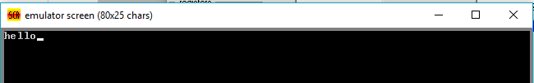

**Output:** -

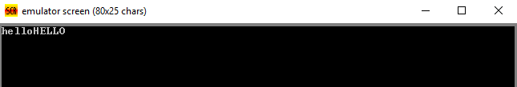

Result: - The program is executed successfully.

Write Assembly Language program in 8086 to check whether inputting the number is greater,smaller or equal to the 5.

**Experiment 9**

**Date: 01/11/2018**

**Program: -**

|  |  |
| --- | --- |
|  | **Name"cmpwithfive”**  **org 100h** |
|  | **jmp start** |
|  |  |
|  | **msg db "Enter a number or any other char to exicute:$"** |
|  | **equal_5 db "is five!",0dh,0ah,"$"** |
|  | **below_5 db "is below five ",0dh,0ah,"$"** |
|  | **above_5 db "is above five ",0dh,0ah,"$"**  **start:** |
|  |  |
|  |  |
|  |  |
|  | **game: mov dx,offset msg** |
|  | **mov ah,09h** |
|  | **int 21h** |
|  |  |
|  | **mov ah,01h** |
|  | **int 21h** |
|  | **cmp al,'0'** |
|  | **jb stop** |
|  |  |
|  | **cmp al,'9'** |
|  | **ja stop** |
|  |  |
|  | **cmp al,'5'** |
|  | **jb below** |
|  | **ja above** |
|  |  |
|  | **mov dx,offset equal_5** |
|  | **jmp print** |
|  |  |
|  | **below:mov dx,offset below_5** |
|  | **jmp print** |
|  |  |
|  | **above: mov dx,offset above_5** |
|  |  |
|  | **print: mov ah,09h** |
|  | **int 21h** |
|  | **jmp game** |
|  | **stop: ret** |

**Output: -**

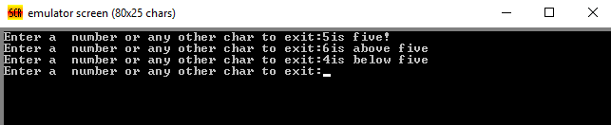

Result: - The program is executed successfully.

Write Assembly Language program in 8086 for comparison of two string.

**Experiment 10**

**Date: 01/11/2018**

**Program: -**

**name "strcmp"**

**org 100h**

**jmp start**

**x1: str1 db 'test string'**

**str2 db 'test string'**

**size=($-x1)/2**

**start: cld**

**mov ax,cs**

**mov ds,ax**

**mov es,ax**

**lea SI,str1**

**lea DI,str2**

**mov cx,size**

**repe cmpsb**

**jnz not_equal**

**mov al,'y'**

**mov ah,0eh**

**int 10h**

**jmp exit_here**

**not_equal: mov al,'n'**

**mov ah,0eh**

**int 10h**

**exit_here: mov ah,0h**

**int 16h**

**ret**

**Output: -**

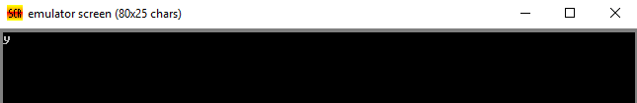

**Result: -** The program is executed successfully.

*Write Assembly Language program in 8086 for comparison of two string word.*

**Experiment 11**

**Date: 01/11/2018**

**Program: -**

**NAME "COMPSW"**

**ORG 100H**

**X: DATA1 DW 1234H,5678H,9012H,3456H**

**DATA2 DW 1234H,5678H,9012H,3456H**

**SIZE=($-X)/4**

**CLD**

**MOV AX,CS**

**MOV DS,AX**

**MOV ES,AX**

**LEA SI,DATA1**

**LEA DI,DATA2**

**MOV CX,SIZE**

**REPE CMPSW**

**JNZ NOT_EQUAL**

**MOV AL,'Y'**

**MOV AH,0EH**

**INT 10H**

**JMP EXIT_HERE**

**NOT_EQUAL: MOV AL,'N'**

**MOV AH,0EH**

**INT 10H**

**EXIT_HERE: MOV AH,0H**

**INT 16H**

**RET**

**Output: -** 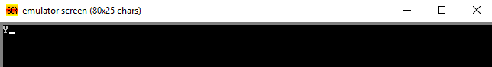

*Write Assembly Language program in 8086 to adding two number using XOR(AAA).*

**Experiment 12**

**Date: 01/11/2018**

**Program: -**

**NAME "AAA"**

**ORG 100H**

**CLD**

**MOV AH,09H**

**MOV AL,05H**

**ADD AL,AH**

**XOR AH,AH**

**AAA**

**MOV DX,AX**

**MOV AH,0EH**

**OR DH,30H**

**MOV AL,DH**

**INT 10H**

**OR DL,30H**

**MOV AL,DL**

**INT 10H**

**MOV AH,0**

**INT 16H**

**RET**

**Output: -**

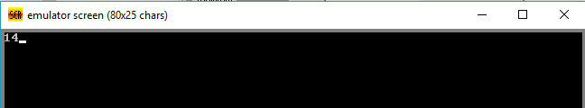

**Result:-** The program was executed successfully.

Write Assembly Language program in 8086 for checking a string for a palindrome.

**Experiment 13**

**Date:**

**Program: -**

**name "pallindrome"**

**org 100h**

**jmp start**

**msg1 db "this is pallindrome $"**

**msg2 db "this is not pallindrome $"**

**m1: s db "able was ere ere sawa elba"**

**s_size=$-m1**

**db 0dh,0ah,'$'**

**start: mov ah,09h**

**mov dx,offset s**

**int 21h**

**lea di,s**

**mov si,di**

**add si,s_size**

**dec si**

**mov cx,s_size**

**cmp cx,01h**

**je is_pallindrome**

**shr cx,01**

**next_char: mov al,[di]**

**mov bl,[si]**

**cmp al,bl**

**jne not_pallindrome**

**inc di**

**dec si**

**loop next_char**

**is_pallindrome: mov ah,09h**

**mov dx,offset msg1**

**int 21h**

**jmp stop**

**not_pallindrome:**

**mov ah,09h**

**mov dx,offset msg2**

**int 21h**

**jmp stop**

**stop: mov ah,00h**

**int 16h**

**ret**

**Output: -**

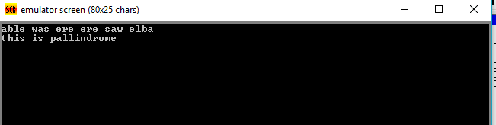

*Write Assembly Language program in 8086 for calculation of the sum of a vector.*

**Experiment 4**

**Date: 01/11/2018**

**Program:-**

|  |  |
| --- | --- |
|  | **name "cal_sum"** |
|  | **org 100H** |
|  | **jmp start** |
|  | **vector db 5,4,3,2,1** |
|  | **start: mov cx,05H** |
|  | **mov al,00H** |
|  | **mov bx,00H** |
|  | **next: add al, vector [bx]** |
|  | **inc bx** |
|  | **loop next** |
|  | **mov bl,al** |
|  | **mov cx,08H** |
|  |  |
|  | **print: mov ah,02H** |
|  | **mov dl,'0'** |
|  | **test bl,10000000B** |
|  | **jz zero** |
|  | **mov dl,'1'** |
|  | **zero: int 21H** |
|  | **shl bl,01H** |
|  | **loop print** |
|  | **mov dl,'B'** |
|  | **int 21H** |
|  |  |
|  | **mov al,0** |
|  | **int 16H** |

**Output:-** 